
Engage

Employee Pension & Financial Wellness App

Staff login details

Download

Location | Name of App. | App Icon
 | Centric Engage Pensions
 | Engage Pensions






Register

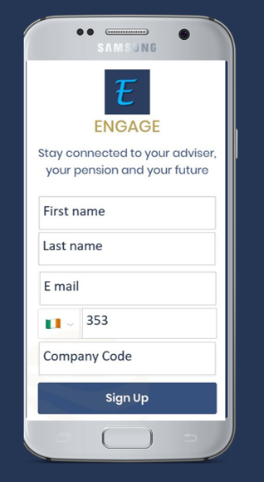

Your Access details

Employer Scheme: _______________________

Company Code: _________________________

Access questions?
E mail info@centric.ie

Adviser logo

